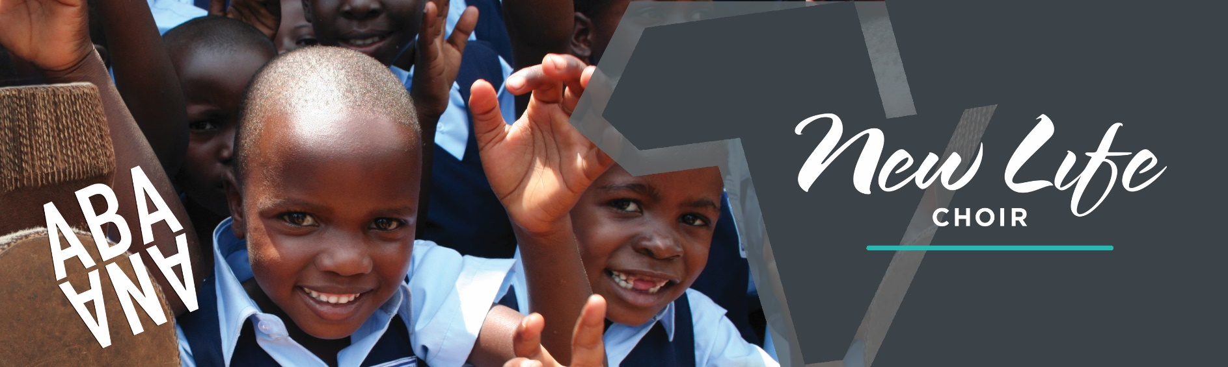

**Choir Chaperone Interest**

**Please print clearly and answer all the questions.**

**Tell us about your education:**

**Title & Name:**

Mr/Miss/Mrs/Other:

First Name:

Surname:

Date of birth:

**Permanent Address:**

Telephone:

Mobile:

E-mail:

**Why do you want to be a chaperone?**

**Gender:** (please circle) Male / Female

Do you hold a **Driving Licence:**

Do you own/have use of a car:

Do you have permission to work permanently in the UK:

Where did you hear about this opportunity:

**What are your hobbies, skills & interests?**

Have you ever been convicted of a criminal offence or have any unspent convictions? 🞎 Yes 🞎 No

Is there any legal reason you would not be allowed to work with children?

🞎 Yes 🞎 No

**Child Protection**

Abaana treats with the utmost seriousness its responsibility to safeguard and protect children and young people by preventing unsuitable people from working with them in paid or voluntary positions.

The successful applicant may be required to undergo an Enhanced Disclosure Certificate from AccessNI confirming the eligibility of the applicant to work with children and young people.

What is your God story – how did you meet Jesus?

What experience and skills do you think you can bring to the choir?

Please tick any of these specific skills you feel you have:

* Leadership (Tour leader)
* Administration
* Merchandise
* Teaching
* Sound & Lighting technician
* Bus driver
* Mini-bus driver
* Van driver

Describe yourself in five words

What would you like to achieve through this opportunity?

**Declaration**

The facts set forth in this application are, to the best of my knowledge, true and complete. I have also read and agree with Abaana’s Statement of Faith overleaf.

Date:

Signature:

What are your available dates?

Please provide two references, from people who know you well and are not relatives. Please include a church leader as one.

Church Leader

Name:

Address:

Phone:

Email:

Other Reference

Name:

Address:

Phone:

Email:

**Return the completed form to:**

### Neville Jones, Abaana, 78 High Street, Bangor, Co. Down, BT20 5AZ.

[neville@abaana.org](mailto:neville@abaana.org) 02891 451918



**STATEMENT OF FAITH**

We believe in...

1. The one true God who lives eternally in three persons—the Father, the Son and the Holy Spirit.

2. The love, grace and sovereignty of God in creating, sustaining, ruling, redeeming and judging the world.

3. The divine inspiration and supreme authority of the Old and New Testament Scriptures, which are the written Word of God—fully trustworthy for faith and conduct.

4. The dignity of all people, made male and female in God's image to love, be holy and care for creation, yet corrupted by sin, which incurs divine wrath and judgement.

5. The incarnation of God’s eternal Son, the Lord Jesus Christ—born of the virgin Mary, truly divine and truly human, yet without sin.

6. The atoning sacrifice of Christ on the cross: dying in our place, paying the price of sin and defeating evil, so reconciling us with God.

7. The bodily resurrection of Christ, the firstfruit of our resurrection; his ascension to the Father, and his reign and mediation as the only Saviour of the world.

8. The justification of sinners solely by the grace of God through faith in Christ.

9. The ministry of God the Holy Spirit, who leads us to repentance, unites us with Christ through new birth, empowers our discipleship and enables our witness.

10. The Church, the body of Christ both local and universal, the priesthood of all believers—given life by the Spirit and endowed with the Spirit's gifts to worship God and proclaim the gospel, promoting justice and love.

11. The personal and visible return of Jesus Christ to fulfil the purposes of God, who will raise all people to judgement, bring eternal life to the redeemed and eternal condemnation to the lost, and establish a new heaven and new earth.